**Database system**

**IMPLEMENATATION ON MYSQL**

**FAIQA LATIF (110790)**

**INSTRUCTOR : MISS SEHRISH KHAN**

**IMPLEMENTATION ON MYSQL**

* Show databases;
* Use dept;

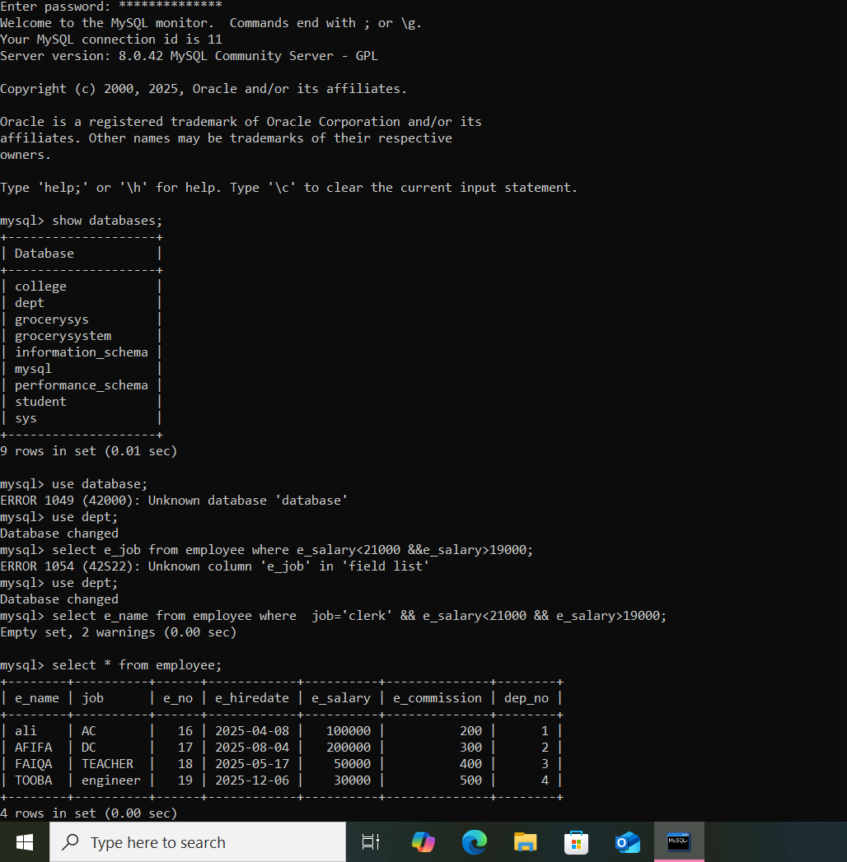

* Select *from employee;



* Query of selecting job ‘AC’ whose salary is less than 200000 and greater than 500 from employee

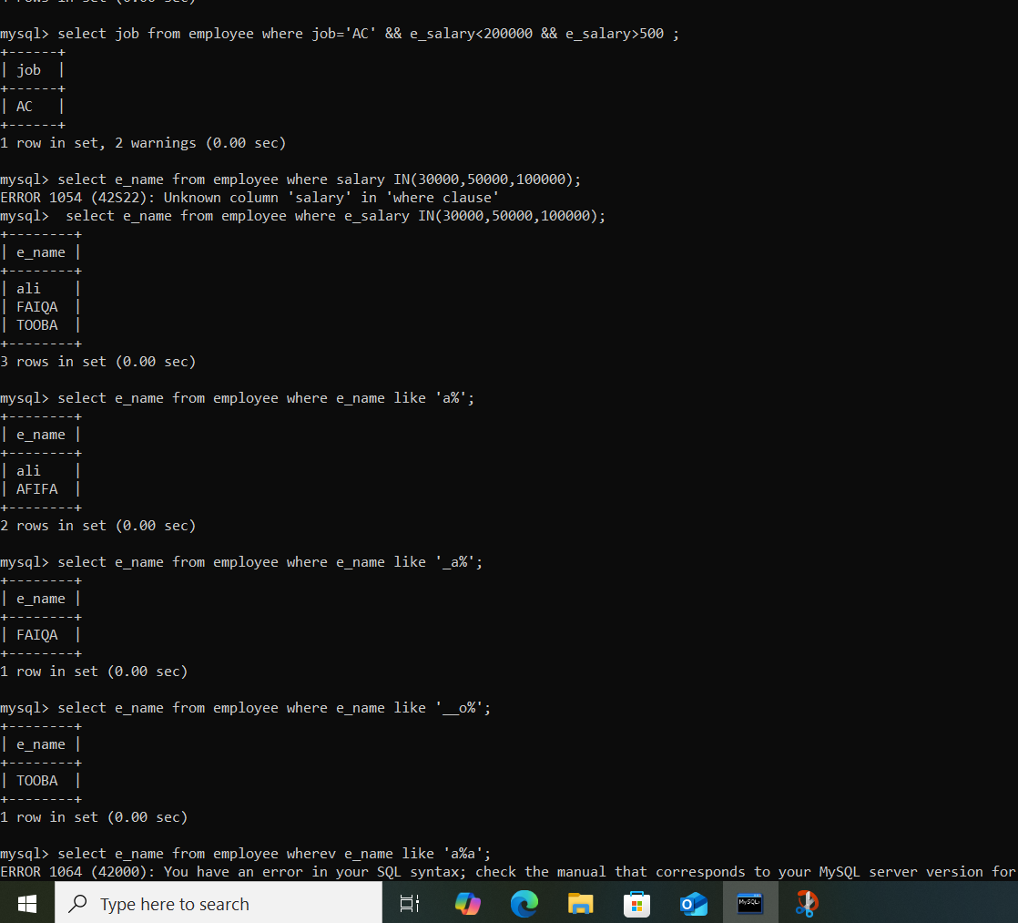

* Query of selecting the name from employee whose salary is 30000,50000,100000



* Query of selecting name of those whose name starts with alphabet ‘a’ from employee table



* Query of selecting name of those whose name second alphabet is ‘a’ from employee table



* Query of selecting name of those whose name third alphabet is ‘o’ from employee table



* Query of selecting name of those whose name last alphabet is ‘a’

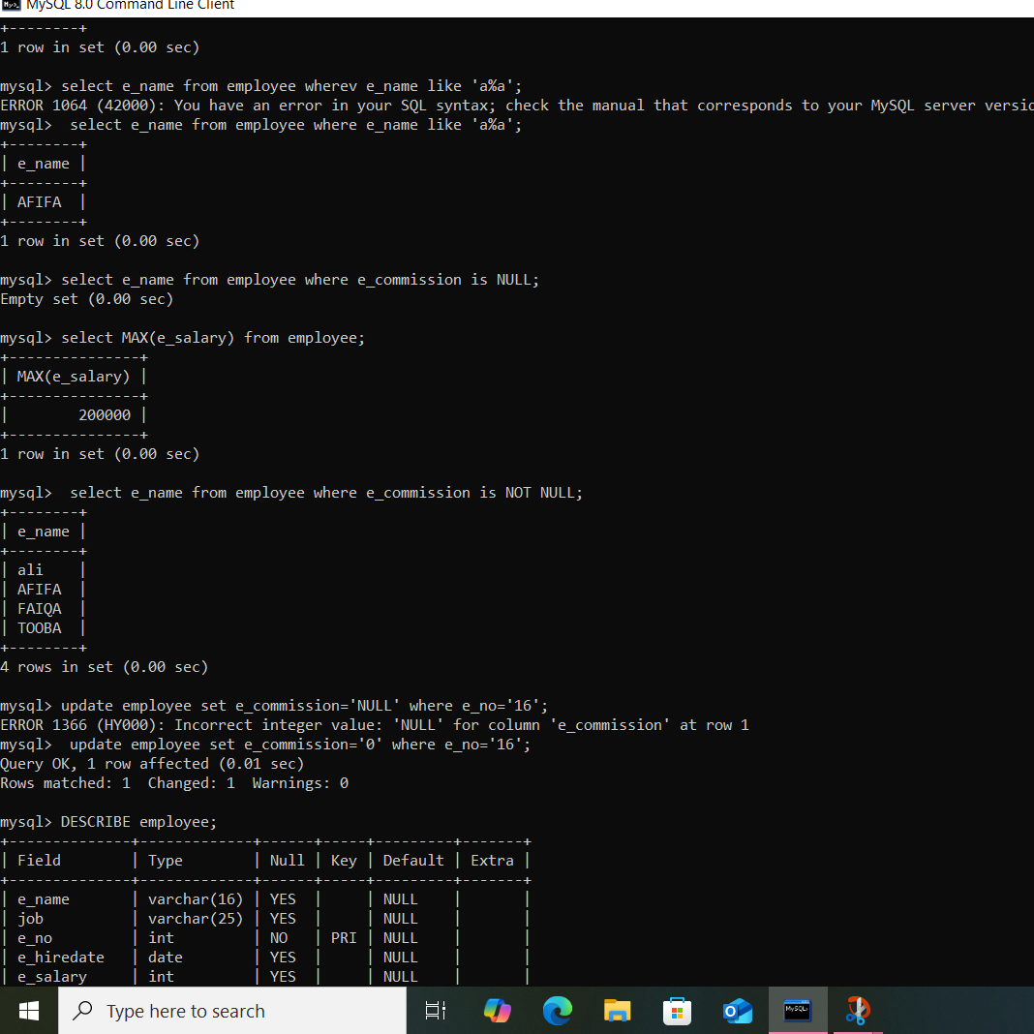

* Query of selecting name of those whose commission is not null



* Update commission= 0 where e_no is 16



* Query of selecting count(*) from employee

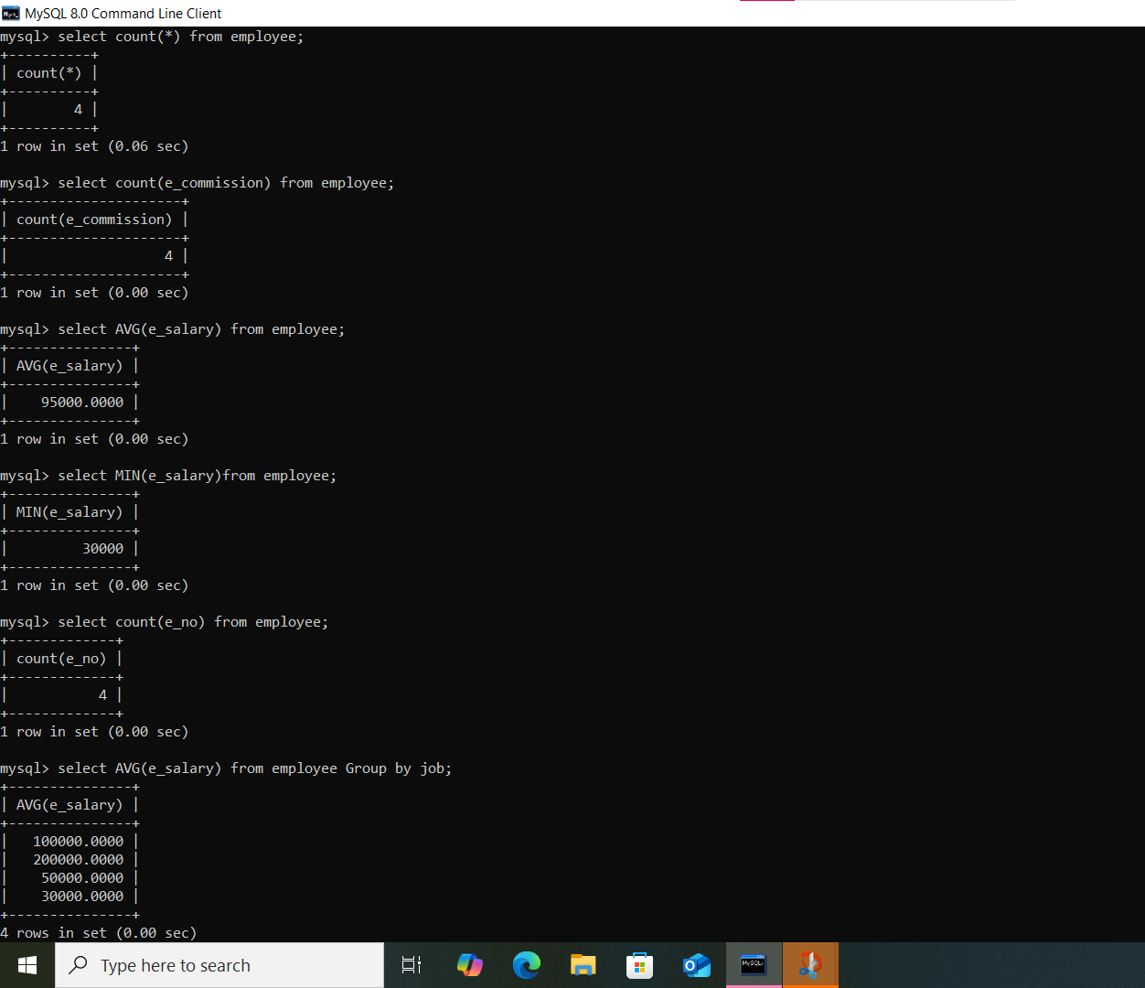

* Query of selecting count(e_commission) from employee



* Query of selecting count(e_no) from employee



* Query of selecting AVG( e_salary) from employee group by job



* Query of selecting MAX(e_salary) from employee group by job

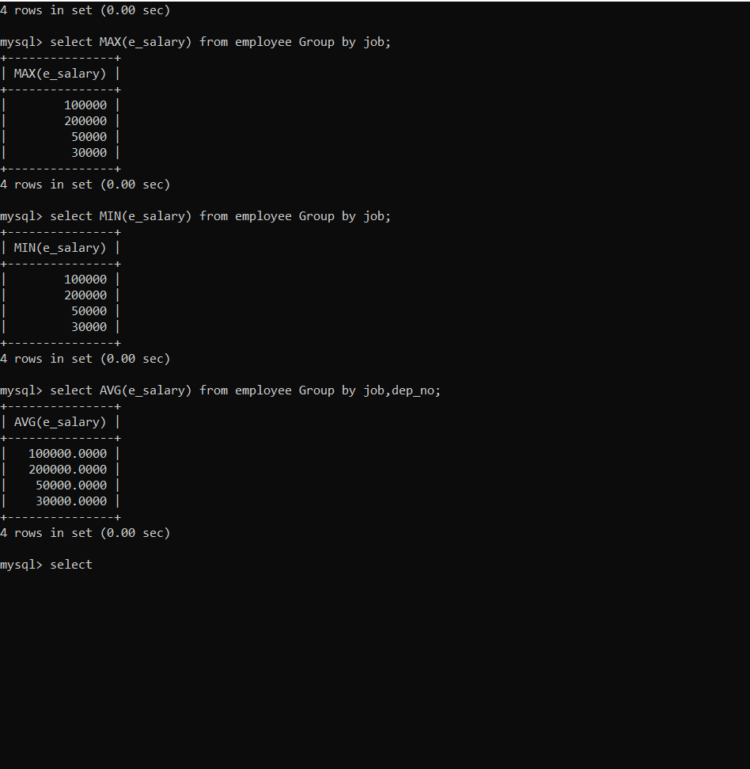

* Query of selecting MIN(e_salary) from employee group by job



* Query of selecting AVG(e_salary) from employee group by job,dep_no



* Select * from employee
* Query of selecting AVG(e_salary) from employee group by job having count(dep_no)>1

